Capital Area
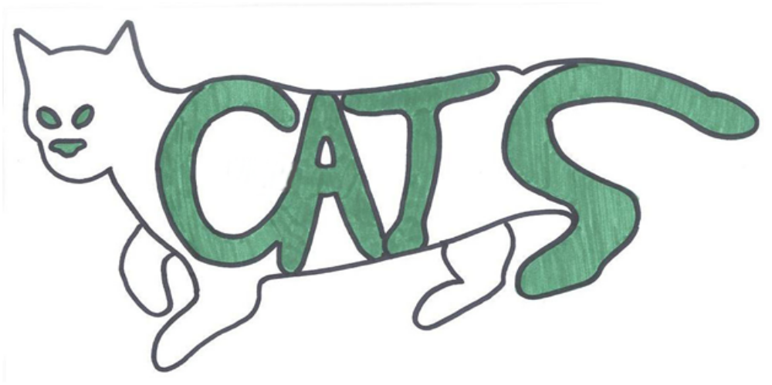Tracking Services

Cody Clarke - Project Team Leader
Sherry Priddy - Project Assistant Team Leader
Jason Baker - Information Analyst
Les Stewart - Data Collection
Randy Guzman - Graphic Artist & Webmaster

TO: TNRM and PALS (Prevent A Litter of Central Texas)
Kate Shaw, President, Board of Directors
From: C.A.T.S. (Capital Area Tracking Services)
Subject: Progress on Plotting of Feral Cat Colonies in Hays County
Date: October 23, 2009
On September 21st, 2009 your organization accepted C.A.T.S. bid to create a comprehensive database and spatial information system that catalogs and maps all feral cat colonies planted and maintained in Hay’s County. We are writing you today to inform you of the progress we have made on the overall project; what’s remaining to be completed, and the challenges the project has encountered. A project chart is enclosed at the end of this report to help you better see where we are on our project.
Work Completed
C.A.T.S. has received all cat data from your organization. We have developed a digital database in excel including all of PALS previous information for all of cats within Hays County. We have also created an active colony database, inactive colony database, (as directed to represent Kyle, Buda, and San Marcos) and a Texas State campus colony database. Incorporated in these files are the addresses of colonies, the number of cats that are living with-in the colony, the care-taker of each colony, and all known ID’s of the cats that were or currently are residing at the colony. You should be able to add more information to these databases upon final project delivery and as needed thereafter.

We have created several base maps that include the San Marcos, Kyle, and Buda roads, municipal land use, and census blocks. We have also mapped preliminary cat colony locations.
Minor discrepancies were found in our initial budget; enclosed is a copy of a revised version. Please refer to the table at the end of this report.
In Progress
We have obtained literature that provides our group more insight into the behavior and habitats of feral cats. With these documents, we have been able to better understand the territory and range of feral cats. For example, we now know that females typically stay with-in the colony, where-as males have more of a tendency to change location. Males have a broader range than females, as well as a larger defense territory. When the cats are neutered or spayed, their ranges decrease. We have also discovered from our preliminary reviews that other, similar GIS projects have had high degrees of success in predicting a species location through habitat analysis. The continuous review of this information will help us formulate our final analysis to predict potential feral cat colonies for PALS.

Our group has been training on a computer program that will enable us to develop interactive online maps that you will able to manipulate. These maps will give you the ability to change your data selections on a base map and view only the desired data such as active or inactive cat colonies. You will be able to interchange these categories whenever data is needed for TNRM activities.
We have begun development of the C.AT.S. website that will ultimately act as a one-stop shop for all project data and information. We will begin adding data after our analysis is complete.
Work to be Completed
For the remainder of our project, we will continue to work on the “In Progress” activities from above. We will begin our analysis and start the following: a detailed report of the team’s project summary and purpose, the data used, the analyses and findings, conclusions, and metadata. Maps of the following are working to fruition:
- Feral cat colonies in San Marcos, Kyle and Buda
- Feral cat colonies in San Marcos, Kyle and Buda with cat territory and range used as zones
- Feral cat colonies in San Marcos, Kyle and Buda and municipal land use
- Feral cat colonies in San Marcos, Kyle and Buda and census blocks with differing income levels
- Feral cat colonies in San Marcos, Kyle and Buda and census blocks with population density
- Feral cat colonies in San Marcos, Kyle and Buda, range zones and corresponding land use, average income labels, and population density labels in each zoned area
- Feral cat colonies in San Marcos, Kyle and Buda and colony predictions

Our group faces only minor challenges that will be solved with-in the week. Buda land use data is being acquired and should be in our hands by this afternoon. We have had some technical issues incorporating excel databases into our analysis program. Again, this issue should be solved with-in the week.
Progress Conclusions
We continue to work on developing the maps, databases and analysis for PALS. Our project is on time and with-in budget. We look forward to presenting our findings and predictions on December 7th, 2009.
Note: Please see attachments

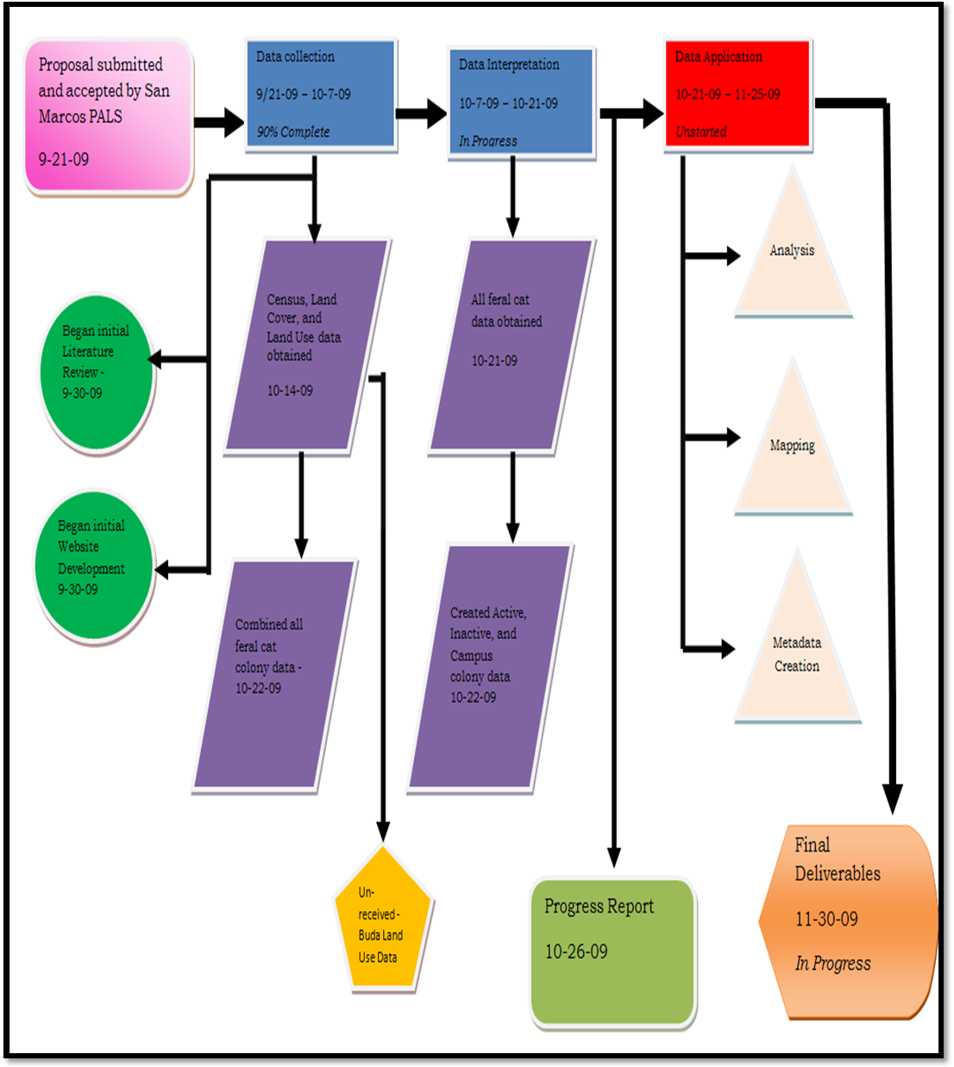
Progress Chart

